MAY 24, 2020 SERVICE
GATHERING

OPENING HYMN “Your Love Oh Lord” (Third Day)
Your love oh Lord reaches to the heavens
Your faithfulness stretches to the skies
And your righteousness is like the mighty mountains
Your justice flows like the ocean’s tide

And I will lift my voice to worship you my king
And I will find my strength in the shadow of your wings

GREETING AND PRAYER OF THE DAY
The grace of our Lord Jesus Christ, the Love of God,
and the unity of the Spirit be with you this day. Let us pray.

Loving and Knowing God, Christ Jesus walked the walk of a life that includes suffering so that we may be freed from our suffering to live knowing that we are your beloved children. Unite us with Christ and with each other, as we face our suffering together, as we rejoice in our triumphs together, knowing that we are always in your gracious presence no matter what comes our way. Amen.

WORD

Psalm 68: 3-10, 32-35
3But let the righteous be glad and rejoice before God;
let them also be merry and joyful.
4Sing to God, sing praises to God’s name; exalt the one who rides the clouds;
I Am is that name, rejoice before God!
5In your holy habitation, O God,
you are a father to orphans, defender of widows;
6you give the solitary a home and bring forth prisoners into freedom;
but the rebels shall live in desert places.
7O God, when you went forth before your people,
when you marched through the wilderness,
8the earth quaked, and the skies poured down rain, at the presence of God, the God of Sinai, at the presence of God, the God of Israel.
9You sent a bountiful rain, O God;
you restored your inheritance when it languished.
10Your people found their home in it;
in your goodness, O God, you have made provision for the poor.
32Sing to God, O kingdoms of the earth; sing praises to the Lord.
33You ride in the heavens, O God, in the ancient heavens;
you send forth your voice, your mighty voice.
34Ascribe power to God,
whose majesty is over Israel; whose strength is in the skies.
35How wonderful you are in your holy places, O God of Israel,
giving strength and power to your people! Blessed be God!

GOSPEL: John 17:1-11
1After Jesus had spoken these words [to his disciples], he looked up to heaven and said, “Father, the hour has come; glorify your Son so that the Son may glorify you, 2since you have given him authority over all people, to give eternal life to all whom you have given him. 3And this is eternal life, that they may know you, the only true God, and Jesus Christ whom you have sent. 4I glorified you on earth by finishing the work that you gave me to do. 5So now, Father, glorify me in your own presence with the glory that I had in your presence before the world existed.
6“I have made your name known to those whom you gave me from the world. They were yours, and you gave them to me, and they have kept your word. 7Now they know that everything you have given me is from you; 8for the words that you gave to me I have given to them, and they have received them and know in truth that I came from you; and they have believed that you sent me. 9I am asking on their behalf; I am not asking on behalf of the world, but on behalf of those whom you gave me, because they are yours. 10All mine are yours, and yours are mine; and I have been glorified in them. 11And now I am no longer in the world, but they are in the world, and I am coming to you. Holy Father, protect them in your name that you have given me, so that they may be one, as we are one.”

MESSAGE
When I look back on my life,
there is one thing that has made the greatest difference for me:
Knowing that I am God’s beloved child.
Knowing that the God who calls me, the God who redeems me,
the God who continues to work upon me, is my God.

It has made a difference in my life to know
that God is always working for my good, no matter what comes my way.
That grace is to be known and experienced, through and through,
and this comes with the reality of a life fully lived,
and everything that comes with it.
The fullness of life for me in the here and now is to know that
I belong to God, and that nothing will ever come between us.

No mistake I make. And I make a lot.
No sin I sin. And it surprises me how often I do sin.
None of my brokenness that persists, despite often thinking
that I am whole enough to perceive and act differently.
No amount of even running away
from the One who never stops running towards me,
and keeps on reminding me: “You Are Mine. There is no where to hide”

In every twist and turn of my journey,
in seasons of great suffering and in seasons of great joy.
it has made the world of the difference to know that I belong to God.

Because it puts a context for my life.
It puts me in a life that is more meaningful, more purposeful, more real,
more hopeful, than it would be if I was just living my life aimlessly alone,
or just with the best of my faculties in each moment,
which I have learned time and time again
can never know the fullness of what this life truly holds for me
despite trying to convince myself otherwise.

Knowing that there is One who is before me, One who is beside me,
One who is behind me, One who cares for me deeply,
One who wants the best for my life,
frees me to live with the greatest courage in everything that I face.
Because I know that there is always One who has my back,
whether I find it hard to put one foot in front of the other,
or whether I am running with ease.

This is the gift that Jesus brings to us all
so we may experience the fullness of life in the here and now.
This is the gift that comes with knowing that the only true God
finishes up the work we need done in our hearts and lives
before our days are through, and brings us into eternity.

And I think that this is the glory of God we see in this life.
It’s not that we are protected from every small thing, or even from big things.
It’s not that we are prevented from experiencing
everything there is to know and experience in this life.
It’s not that we stop living the depth of what it means to be human,
in all of its anxiety, and frailty, and fragility,
or that we are always kept from suffering.
Even all of those things that we try to avoid
have a depth of meaning within them to be found.

The glory of God we glimpse in this life is found in our courage to continue living no matter what we face, because we know we are God’s beloved.
For no matter what we go through,
we can trust that there will be something worth our while
in every season, because we know God is there with us.
There is purpose. There is meaning. There is hope.
There is a real life to be lived,
a real life to live knowing that we belong to God.

But lets face it-we live in a time and place that seeks to tell us otherwise.
How often are we deterred from seeing a holy metanarrative for our lives,
and from knowing that it actually all has meaning and purpose,
because we belong to God.

Perhaps one of the hardest things for us in this day and age
is to stand firm in the reality that knowing we belong to God
is the most real reality we could live.

Today I invite you to ponder upon
where you need to know God more in your life,
where God needs to be more real for you.

Where is it that you need to know that you belong to God,
that God is your God, and God has something for you in this moment?

How do you need to know God’s protecting arm is with you,
even if you have been through a season that feels like a prison or a desert,
or a time that you may have yearned for more stability?

Sometimes it is difficult to comprehend that the Great I Am
is looking at us from upon the heavens, is guarding our broken hearts,
is caring for our aching souls.

Sometimes it is hard to understand that the Power of God
is most powerfully known within the depths of our aching souls
and crevasses of our broken hearts,
that God continues to be seen and known in and through our suffering.
That the fact we may suffer does not mean that God is absent
or that we are far from God, or that we have stopped belonging to God.

Sometimes it is difficult to understand
that we do not need to fear the outcome of our trials,
because the God to whom we belong will get us through it all,
and will give to us a great gift of grace that would not have come to us
had we not gone through it in the first place.
There is great meaning and purpose to be found, even through our trials.

Our psalm today depicts the history of Israel,
and the goodness of God that came to them
when they were stuck in the prison of slavery,
stuck in the journey through the desert,
stuck in the life of vulnerability,
stuck without no one else to turn to but God.

Sometimes, it’s OK to be stuck without anyone else but God to turn to.
Because God will show up.
And we will be reminded that being stuck
is not the worst thing in the world.
Because we will be freed soon enough.

The rains will come soon enough
to refresh our parched and weary hearts.
God’s blessings will come soon enough to revive us again,
to bring us joy again.

And when they do, we will know who is the only true God,
and how truly beloved we are, and we will hold up our heads again,
singing praises to the One to whom we belong.

HYMN OF THE DAY #581 “You Are Mine”

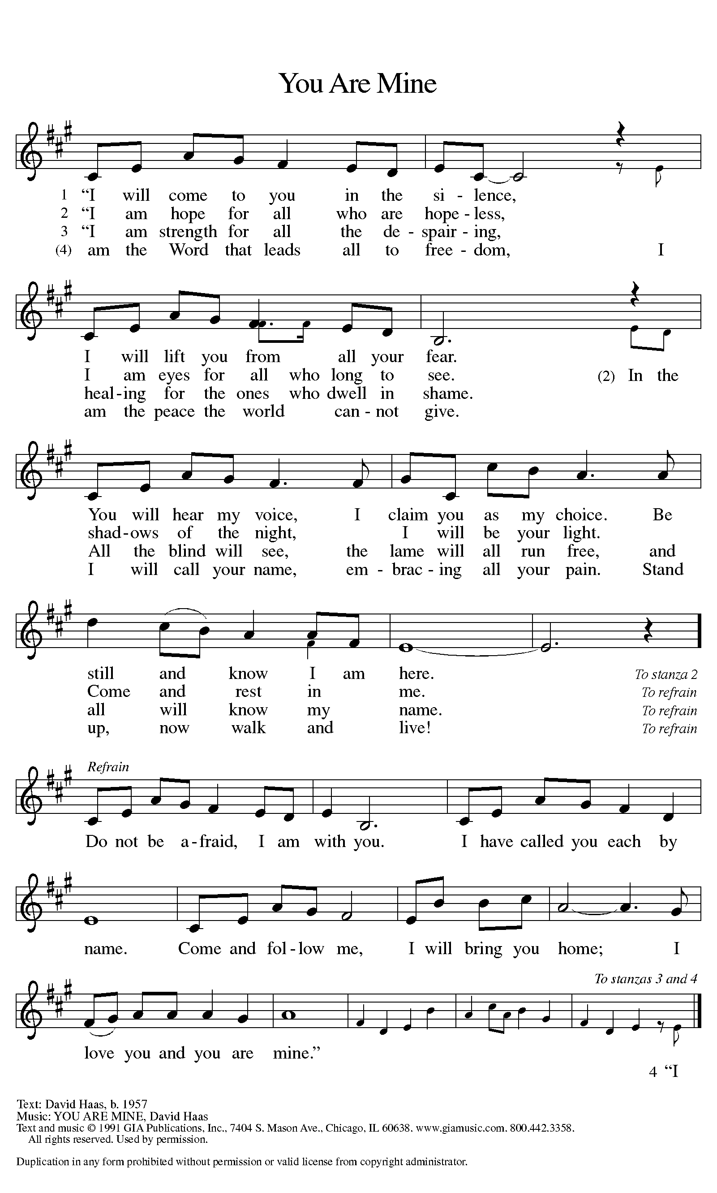
PRAYERS OF INTERCESSION
God of Truth, unite us in your truth: you love us all and we all belong to you. Help us to live our lives knowing this. God of grace: Help us know you.

God of Life, breathe life into the work of your creation.
Enrich our understanding to see how all of your world is one.
God of grace: Help us know you.

God of Justice, make your justice known among the nations of the earth. Protect the vulnerable, especially those who are suffering from war and crisis. Redirect those who use violence and greed as weapons.
God of grace: Help us know you.

God of Love, come to the aid of your beloved children. Bring solace to those engulfed in grief, those without supportive families, and all who are isolated, powerless, anxious, or afraid. Help us all trust in your care.
God of grace: Help us know you.

God of Courage, give courage to all who embark on new ventures as we learn to emerge from our homes, and live our lives safely. Give us strength to continue in this difficult time. God of grace: Help us know you.

God of Eternity, bring all your beloved to eternal life. Until that day, we give you thanks to those who have listened to your voice and now rest in you.
God of grace: Help us know you.

With bold confidence in your love, Gracious God, we place all for whom we pray into the fullness of you care; through Christ our Lord, the One to whom we all belong. Amen.

LORD’S PRAYER
Our Father in heaven, hallowed be your name,
your kingdom come, your will be done, on earth as in heaven.
Give us today our daily bread.
Forgive us our sins as we forgive those who sin against us.
Save us from the time of trial and deliver us from evil.
For the kingdom, the power, and the glory are yours,
now and forever. Amen.

SENDING
CLOSING HYMN “Good Good Father” (Chris Tomlin)

Verse 1
I've heard a thousand stories
Of what they think You're like
But I've heard the tender whisper
Of love in the dead of night and You
Tell me that You're pleased and that
I'm never alone

Chorus
You're a good, good Father,
It's who You are, it's who You are,
It's who You are
And I'm loved by You
It's who I am, it's who I am
It's who I am

Verse 2
Oh and I've seen many searching for
Answers far and wide, but I know we're all
Searching for answers only You provide because
You know just what we need before
We say a word

Bridge
Because You are perfect
In all of Your ways
You are perfect in all of Your ways
You are perfect in all of Your ways
To us

Verse 3
Oh this Love so undeniable
I, I can hardly speak
Peace so unexplainable
I, I can hardly think as You
Call me, deeper still as You
Call me deeper still as You call
Me deeper still into love
Love, love

Chorus |2x|

BLESSING
May the One who brought forth Jesus from the dead
raise you to new life, fill you with hope,
and turn your mourning into dancing.
Almighty God, Creator, Redeemer, Sustainer,
bless you now and forever. Amen.

DISMISSAL
Be at peace. You belong to Christ. Christ is with you always.

